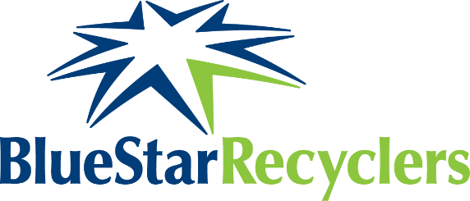
Sam Morris – BIO
Sam Morris is the Chief Executive Officer for Blue Star Recyclers, a Colorado-based social enterprise founded in 2009 with a mission of recycling electronics to create jobs for people with autism and other disAbilities.

Sam joined Blue Star in 2015 as Director of Operations, based out of the Colorado Springs recycling operation. In 2019 he took over as CEO with overall responsibility for the four Blue Star locations in Colorado and the expansion location in Chicago.

Sam is an advocate for giving customers a simple model to embrace environmental accountability while investing in their local communities.

Recent professional accomplishments for Sam and Blue Star include Nonprofit of the Year (2018) and recognition as a ColoradoBiz Top 25 Young Professionals (2020).

